Structured Inquiry

Create a maven project with all dependencies required for the application in CI/CD pipeline.

Section 1:

Step 1: Java has been already installed check the version

Step 2: Install Maven using below Command

CMD : sudo apt update
sudo apt install maven -y

Step 3: Create Maven Project
run the below command

CMD:
mvn archetype:generate -DgroupId=com.example.app \
-DartifactId=demo-app \
-DarchetypeArtifactId=maven-archetype-quickstart \
-DinteractiveMode=false

This will create a project with name demo-app

Step 4: change the directory to demo-app using below command

CMD : cd demo-app

Step 5: list all the files from the demo-app directory

CMD : ls
o/p: pom.xml , src

Step 6: Understand the project structure

demo-app/
├── pom.xml
├── src/
│ ├── main/java
│ └── test/java

Step 7: edit the pom.xml

CMD: nano pom.xml

add the below sections to pom.xml

<project xmlns="http://maven.apache.org/POM/4.0.0" xmlns:xsi="http://www.w3.org/2001/XMLSchema-instance"
xsi:schemaLocation="http://maven.apache.org/POM/4.0.0 http://maven.apache.org/maven-v4_0_0.xsd">
<modelVersion>4.0.0</modelVersion>
<groupId>com.example.app</groupId>
<artifactId>demo-app</artifactId>
<packaging>jar</packaging>
<version>1.0-SNAPSHOT</version>
<name>demo-app</name>
<url>http://maven.apache.org</url>
<dependencies>
<dependency>
<groupId>ch.qos.logback</groupId>
<artifactId>logback-classic</artifactId>
<version>1.4.14</version>
</dependency>

<!-- JUnit for testing -->
<dependency>
<groupId>junit</groupId>
<artifactId>junit</artifactId>
<version>4.13.2</version>
<scope>test</scope>
</dependency>

<!-- Logging -->
<dependency>
<groupId>org.slf4j</groupId>
<artifactId>slf4j-api</artifactId>
<version>2.0.9</version>
</dependency>

<!-- Apache Commons -->
<dependency>
<groupId>org.apache.commons</groupId>
<artifactId>commons-lang3</artifactId>
<version>3.14.0</version>
</dependency>

</dependencies>
<build>
<plugins>

<!-- Compiler Plugin -->
<plugin>
<groupId>org.apache.maven.plugins</groupId>
<artifactId>maven-compiler-plugin</artifactId>
<version>3.11.0</version>
<configuration>
<source>17</source>
<target>17</target>
</configuration>
</plugin>

<!-- Test Plugin -->
<plugin>
<groupId>org.apache.maven.plugins</groupId>
<artifactId>maven-surefire-plugin</artifactId>
<version>3.1.2</version>
</plugin>

</plugins>
</build>
</project>

save and exit nano using ctrl+O, Enter and ctrl+X

Step 8: Write the java application code

CMD: nano src/main/java/com/example/app/App.java

copy the below code to App.java

package com.example.app;

import org.slf4j.Logger;
import org.slf4j.LoggerFactory;
import org.apache.commons.lang3.StringUtils;

public class App {

private static final Logger logger = LoggerFactory.getLogger(App.class);

public static void main(String[] args) {
String name = "CI/CD Pipeline";

if (StringUtils.isNotBlank(name)) {
String message = greet(name);
logger.info(message);
System.out.println(message);
} else {
logger.error("Name is empty!");
}
}

public static String greet(String name) {
return "Hello, " + name + "! Welcome to Maven CI/CD Demo.";
}
}

Step 9: Write test code

CMD: nano src/test/java/com/example/app/AppTest.java

copy the below code to AppTest.java

package com.example.app;

import org.junit.Test;
import static org.junit.Assert.assertEquals;

public class AppTest {

@Test
public void testGreet() {
String result = App.greet("Student");
assertEquals("Hello, Student! Welcome to Maven CI/CD Demo.", result);
}
}

Step 10: Build the project

CMD: mvn clean install

Step 11: Run the application

CMD: mvn exec:java -Dexec.mainClass="com.example.app.App"

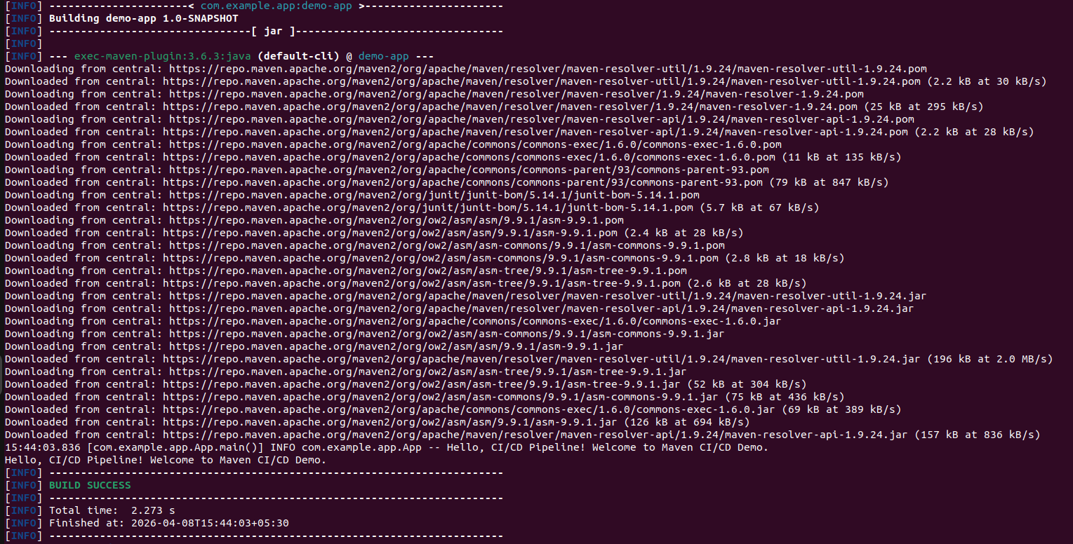
output:

Hello, CI/CD Pipeline! Welcome to Maven CI/CD Demo.
Hello, CI/CD Pipeline! Welcome to Maven CI/CD Demo.

Section 2:

Push the above demo-app directory to github by creating new repo, create a Jenkinsfile and add the below code to Jenkinsfile

pipeline {
agent any

tools {
maven 'Maven3'
jdk 'JDK17'
}

stages {

stage('Checkout') {
steps {
git 'https://github.com/Naveen04jan/demo-app.git'
}
}

stage('Build') {
steps {
sh 'mvn clean compile'
}
}

stage('Test') {
steps {
sh 'mvn test'
}
}

stage('Package') {
steps {
sh 'mvn package'
}
}
}
}

Steps to run jenkins: Follow the same procedure for running the jenkins server from experiment 3 and 5 create the new pipeline in jenkins and build the pipeline.

